Updated deploy.js file with proper instance info

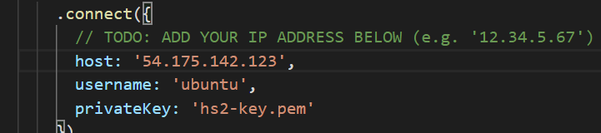

Add deploy.sh files

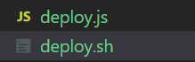

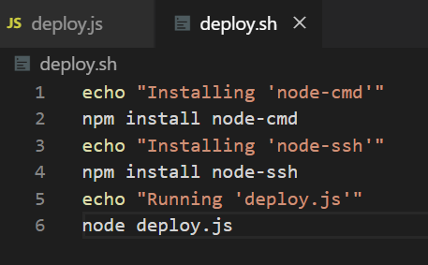

Add .travis.yml file

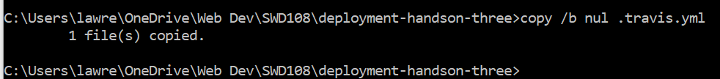



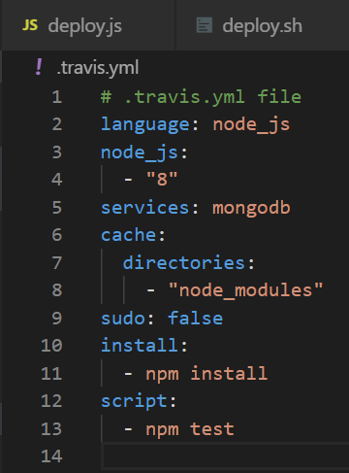

Connect Travis CI to todo list

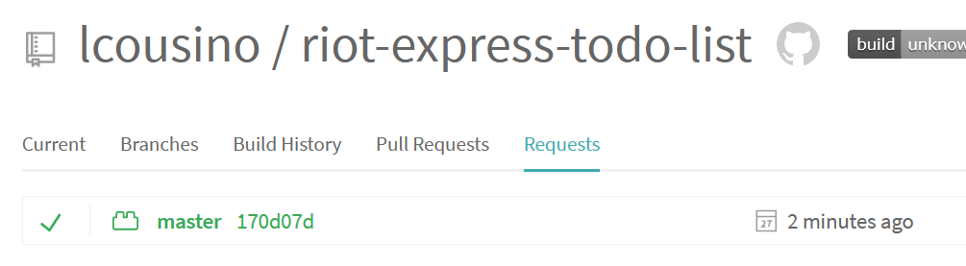

Update .yml file

Changed README file to confirm automation

